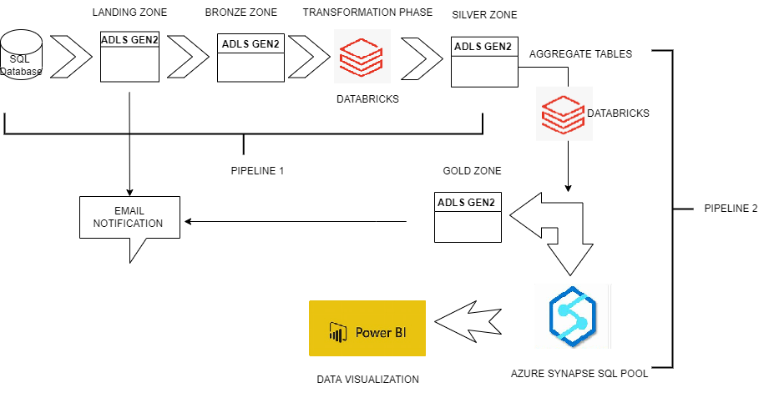

Pipeline 1

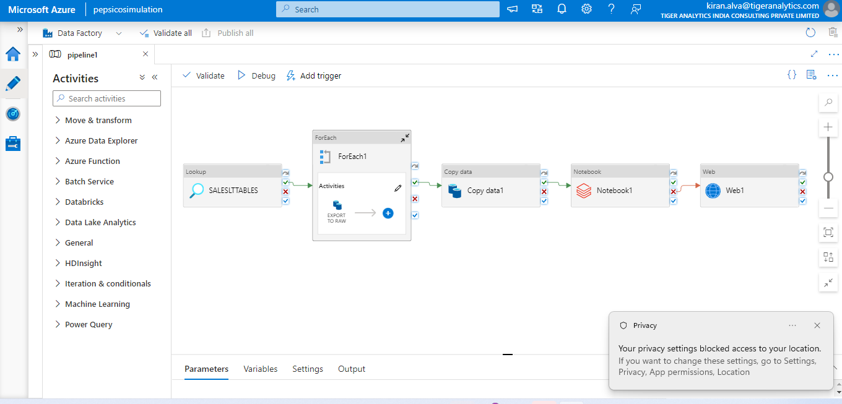

Pipeline 2

Data Visualisation

